WHAT’S SILLY HAIR DAY WITH NO HAIR?
Discussion Questions

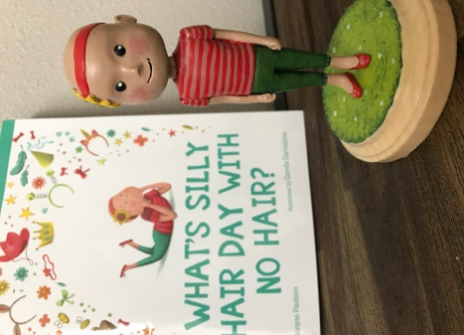

Before Reading

1. Share a time when you felt left out? How did that make you feel?
2. What does it mean to be a good friend?

During Reading

1. Bea’s tried several ideas to help her fit in on Silly Hair Day but none were quite right. What should Bea do? Share your ideas.

After Reading

1. Bea changed “Silly Hair Day” to “Silly Hair or Head Day” so everyone could be included in the fun. If you could change one thing, what would you change about your school or community? How would you make that change happen?

